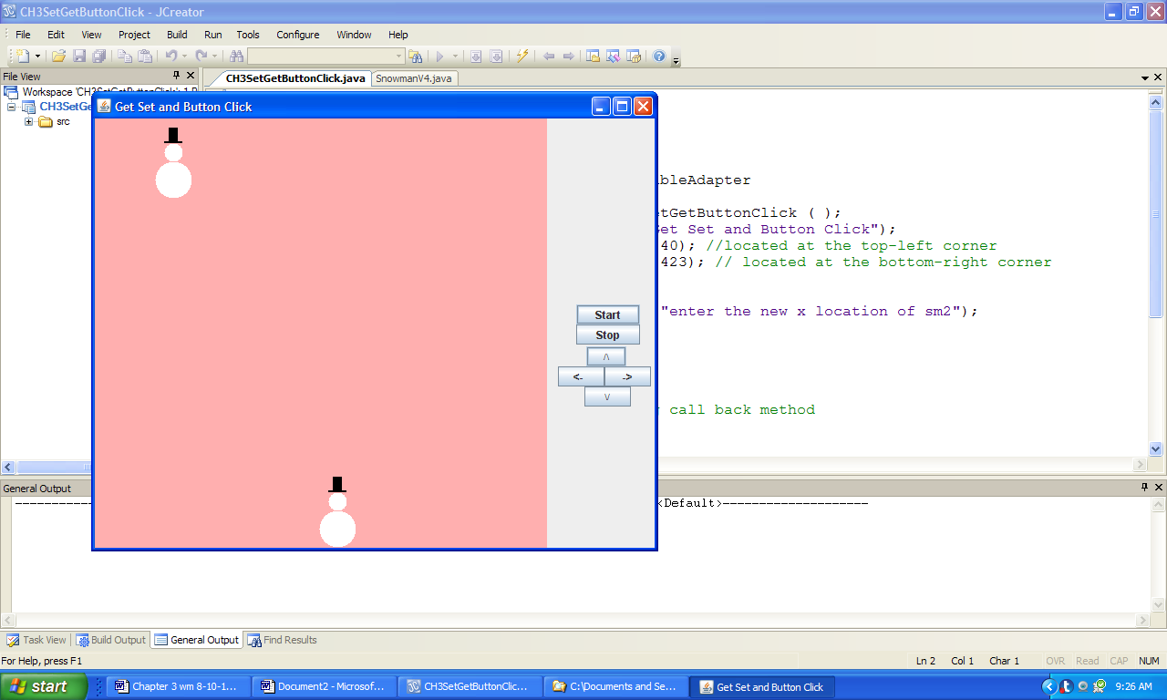

**Figure 3.31 The output of the application SetGetButtonClick after the snowmen are relocated.**